# Links

Team name: Friday-4

Github link: <https://github.com/RMIT-SEPT/majorproject-1-fri-10-30-4>

Clickup link: <https://app.clickup.com/6915050/v/l/6-13211523-1>

CircleCI link:   
AWS links::

# Peer review

|  |  |
| --- | --- |
| **Person** | **Contribution** |
| Harrison |  |
| Nikita |  |
| Michael |  |
| Joel |  |
| Jasper |  |

# User Stories Summary

Groomed Product Backlog:

Note that the ID’s are inconsistent due to the grooming process (we had to remove some stories that seemed irrelevant, etc).

|  |  |  |
| --- | --- | --- |
| ID | Story | Points |
| 1 | As a user, I would like to be able to login into my account, so that I may access my account privileges. | 5 |
| 2 | As a customer, I want to be able to register a new account with the site, so that I can create a booking. | 21 |
| 3 | As a customer I want to be able to view my previous bookings, so I can access receipts and details of my previous bookings. | 8 |
| 4 | As a customer, I want to be able to cancel my bookings 48 hours in advance, so that I can make bookings far into the future with the confidence I can cancel if something comes up. | 13 |
| 6 | As a business administrator, I want to be able to register new worker accounts with the site so I can easily sign up my own teams. | 15 |
| 7 | As a business administrator I would like to edit employee information, so that their information is up to date. | 21 |
| 8 | As a business administrator, I would like to view workers' availability for the next 7 days, so that I can see which workers are available for service. | 8 |
| 9 | As a business administrator I would like to view the summary of past bookings (sorted by date), so that I can see information regarding the past booking. | 8 |
| 11 | As a worker, I want to check the worker's calendar, so that I can check how many appointments I have. | 21 |
| 13 | As a customer , I would like to check when a particular staff member has available booking, so that I can close an appointment with my favorite staff member. | 21 |
| 17 | As a customer I would like to be able to make booking for a service at a day and time that I like | 34 |
| 18 | As a business owner, I would like to login, so I can manage my business. | 21 |
| 19 | As a business owner, I would like to remove employees from my business, so that only relevant Employees are in my business | 15 |
| 20 | As an admin I would like to view my profile page so that I can see that my details are up to date. | 15 |
| 21 | As a customer I would like to be able to make booking for a service at a day and time that I like | 21 |
| 22 | As an admin I would like to view an Employee's profile page so that I can see that their details are up to date. | 8 |
| 23 | As a customer, I would like to login, so I can use the services | 21 |

Link: <https://docs.google.com/spreadsheets/d/1Hox8Hyh_6s3p20xVTfI_6Qr-xOtCP-R-LF8Wt-ZiuI4/edit?usp=sharing>

# Meeting Minutes

Sprint 3:

<https://docs.google.com/document/d/1M2KKzxXr-SN5AO8V9VQytoUQCbMKemFqD5Ocm0lB6SE/edit?usp=sharing>

Sprint 4: <https://docs.google.com/document/d/1Q_iSeZlHhx24AfhmdrwMAaHMNvSq60U4YUUZCt49fvk/edit?usp=sharing>

# 

# Project Report

## Vision statement

The API provides a prebuilt solution for businesses looking to allow customers to book appointments directly with employees through an online application. The API is flexible and should allow a wide variety of business applications to be built on top of it.

## System architecture

## Refactoring

Throughout the process of developing the application, we refactored the way that entities relating to people were stored. Originally we had three classes (worker, admin, customer) extending a shared user class, we eventually went with three classes, Workers, Admins and Customers, with Admin and Customer both having an association with a “User” object for login.

Additionally we made significant changes to the visual aesthetics of the frontend over time, as we finalized what the business was going to be.

## Deployment Pipeline

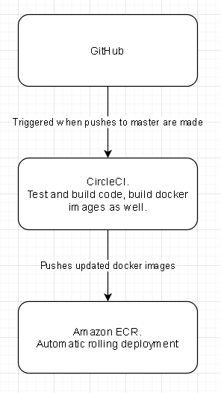

When code is merged onto the master branch in github, CircleCI will checkout this code and build a new docker image containing the updated frontend and backend.

## Acceptance test cases:

Acceptance test documentation is stored in ClickUp.

## Test Execution

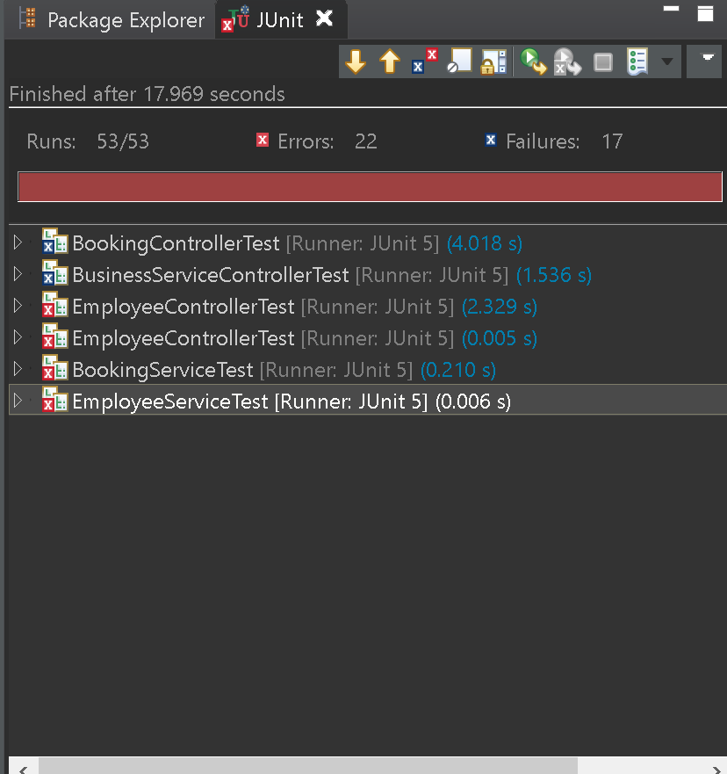

As well as executing tests locally, unit tests are run in CircleCI prior to the build and deploy steps.

## 

## 

## 

## 

## Bug Reports

|  |  |
| --- | --- |
| Issue #1 | 'Cancel' button in the frontend deletes all bookings.  Note: Cancelling a booking in the backend works as intended. |
| Steps to reproduce the issue | 1. Create a booking in the frontend. 2. Use Postman to get all bookings to check the booking has been made 3. Cancel the booking in either Admin or Customer account 4. Use Postman to get all bookings to check the booking has been cancelled (in this case, all the bookings get removed some how). |
| Possible locations that the problem could be stemming from | 1. Bookings.js (Customer folder) 2. Booking.js (Admin folder) |